1. To help you practice strategies for machine learning, this week we’ll present another scenario and ask how you would act. We think this “simulator” of working in a machine learning project will give an idea of what leading a machine learning project could be like!

You are employed by a startup building self-driving cars. You are in charge of detecting road signs (stop sign, pedestrian crossing sign, construction ahead sign) and traffic signals (red and green lights) in images. The goal is to recognize which of these objects appear in each image. As an example, this image contains a pedestrian crossing sign and red traffic lights.

Your 100,000 labeled images are taken using the front-facing camera of your car. This is also the distribution of data you care most about doing well on. You think you might be able to get a much larger dataset off the internet, which could be helpful for training even if the distribution of internet data is not the same.

You are getting started with this project. What is the first thing you do? Assume each of the steps below would take about an equal amount of time (a few days).

Train a basic model and do error analysis.

1. Your goal is to detect road signs (stop sign, pedestrian crossing sign, construction ahead sign) and traffic signals (red and green lights) in images. The goal is to recognize which of these objects appear in each image. You plan to use a deep neural network with ReLU units in the hidden layers. For the output layer, which of the following gives you the most appropriate activation function?

Sigmoid.

1. You are carrying out error analysis and counting up what errors the algorithm makes. Which of these datasets do you think you should manually go through and carefully examine, one image at a time?

500 images on which the algorithm made a mistake.

1. After working on the data for several weeks, your team ends up with the following data:

* 100,000 labeled images taken using the front-facing camera of your car.
* 900,000 labeled images of roads downloaded from the internet.
* Each image’s labels precisely indicate the presence of any specific road signs and traffic signals or combinations of them. For example, $y^{(i)}=\left[\begin{matrix}1 \\ 0 \\ \begin{matrix}0 \\ 1 \\ 0\end{matrix}\end{matrix}\right]$ means the image contains a stop sign and a red traffic light.

When using a non fully labeled image such as , $y^{(i)}=\left[\begin{matrix}0 \\ ? \\ \begin{matrix}1 \\ ? \\ 1\end{matrix}\end{matrix}\right]$ ​, which of the following strategies is most appropriate to calculate the loss function to train as a multi-task learning problem?

Calculate the loss as $\sum{L}({\hat{y}}_{j}^{\left(i\right)},y_{j}^{\left(i\right)}$ where the sum goes over all the know components of $y^{\left(i\right)}$.

1. The distribution of data you care about contains images from your car’s front-facing camera; which comes from a different distribution than the images you were able to find and download off the internet. How should you split the dataset into train/dev/test sets?

Choose the training set to be the 900.000 images from the internet along with 80.000 images from your car’s front-facing camera. The 20.000 remaining images will be split equally in dev and test sets.

1. Assume you’ve finally chosen the following split between the data:

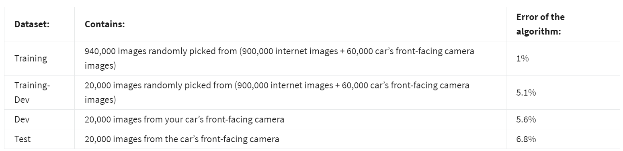

You also know that human-level error on the road sign and traffic signals classification task is around 0.5%. Which of the following is true?

You have a high variance problem.

1. Assume you’ve finally chosen the following split between the data:

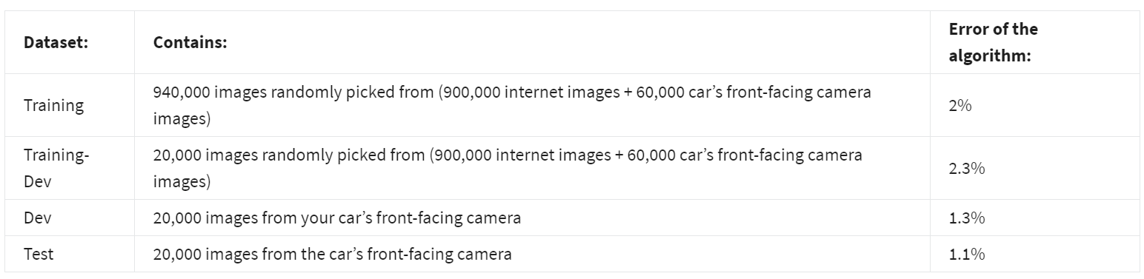

You also know that human-level error on the road sign and traffic signals classification task is around 0.5%. Based on the information given you conclude that the Bayes error for the dev/test distribution is probably higher than for the train distribution. True/False?

False.

1. You decide to focus on the dev set and check by hand what are the errors due to. Here is a table summarizing your discoveries:

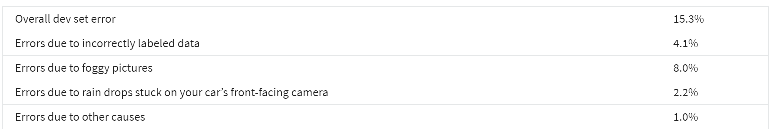

In this table, 4.1%, 8.0%, etc. are a fraction of the total dev set (not just examples of your algorithm mislabeled). For example, about 8.0/15.3 = 52% of your errors are due to foggy pictures.

The results from this analysis implies that the team’s highest priority should be to bring more foggy pictures into the training set so as to address the 8.0% of errors in that category. True/False?

Additional note: there are subtle concepts to consider with this question, and you may find arguments for why some answers are also correct or incorrect. We recommend that you spend time reading the feedback for this quiz, to understand what issues that you will want to consider when you are building your own machine learning project.

False because it depends on how easy it is to add foggy data. If foggy data is very hard and costly to collect, it might not be worth the team’s effort.

1. You can buy a specially designed windshield wiper that helps wipe off some of the raindrops on the front-facing camera.

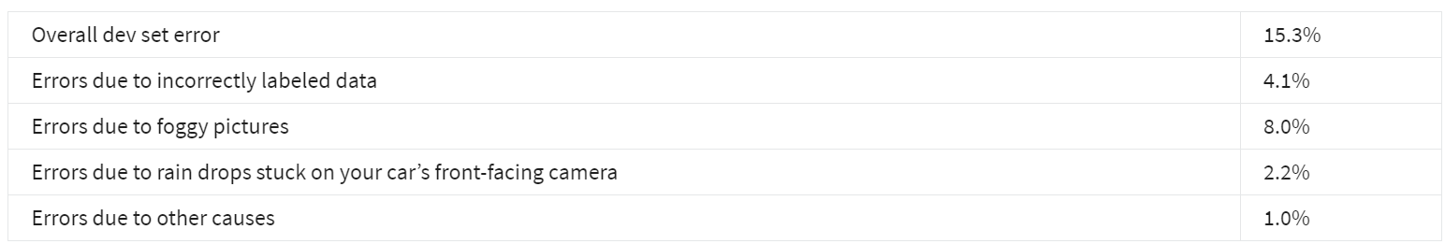

Which of the following statements do you agree with?

2.2% would be reasonable estimate of the maximum amount this windshield wiper could improve performance.

1. You decide to use data augmentation to address foggy images. You find 1,000 pictures of fog off the internet, and “add” them to clean images to synthesize foggy days, like this:

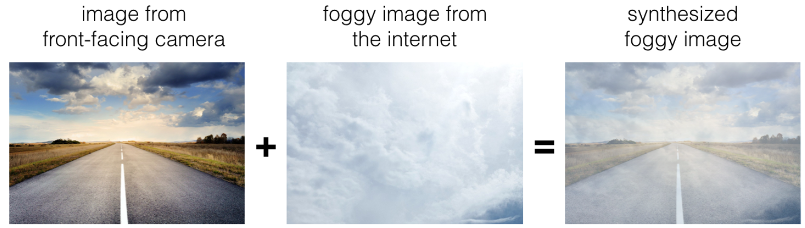

Which of the following do you agree with?

If used, the synthetic data should be added to the training set.

1. After working further on the problem, you've decided to correct the incorrectly labeled data. Your team corrects the labels of the wrongly predicted images on the dev set. Which of the following is a necessary step to take?

Correct the labels of the test set.

1. Your client asks you to add the capability to detect dogs that may be crossing the road to the system. He can provide a relatively small set containing dogs. Which of the following do you agree most with?

You can use weight pre-trained on the original data, and fine-tune with the data now including the dogs.

1. One of your colleagues at the startup is starting a project to classify road signs as stop, dangerous curve, construction ahead, dead-end, and speed limit signs. He has approximately 30,000 examples of each image and 30,000 images without a sign. This case could benefit from using multi-task learning. True/False?

True.

1. To recognize red and green lights, you have been using this approach:

**(A)** Input an image (x) to a neural network and have it directly learn a mapping to make a prediction as to whether there’s a red light and/or green light (y).

A teammate proposes a different, two-step approach:

**(B)** In this two-step approach, you would first (i) detect the traffic light in the image (if any), then (ii) determine the color of the illuminated lamp in the traffic light.

Between these two, Approach B is more of an end-to-end approach because it has distinct steps for the input end and the output end. True/False?

False.

1. An end-to-end approach doesn't require that we hand-design useful features, it only requires a large enough model. True/False?

True.